Development of Contactless Employee Management System with Mask Detection and Body Temperature Measurement using TensorFlow
Objective:
Aim of the project is to build a smart employee management system which should be contactless, able to perform mask detection, body temperature detection and contain sanitizer dispensing unit.
Abstract:
CoVID-19 pandemic signified the importance of social distancing and non-contact routines. Even after the pandemic, everyone should abide by the same protocols for a hygienic life. Institutions must put in place pre-emptive measures before people return. These include marking the presence of employees and monitoring their health status. This paper focuses on developing a contactless employee management system with sensor fusion and deep learning technology. It can perform the attendance routine without compromising the safety measures. Employees can be identified using random QR code recognition which can avoid the mask removal to perform employee recognition. While recognizing the QR, system will double verify the employee by detecting the MAC address of is mobile Bluetooth at backend. It can eliminate fake attendance system. After employee identification system will perform mask detection process. To detect the mask, system uses the pre-trained deep learning model. That deep learning model is generated by CNN algorithm which can classify “Face with mask” and “Face with No mask”. After successful completion of mask detection, system checks the employee body temperature by IR temperature sensor followed by sanitizer dispensing action. Response for the whole process will be updated to employee’s mobile application as well as Employee Management Authority (EMA).
Existing System:
Existing system uses two different cameras to recognize the employee and his body temperature. In that process, employee needs to remove his mask for face recognition. For temperature detection system uses Thermal camera which is costlier than IR temperature sensor.
Proposed System:
Proposed system uses two factor employee authentication processes to ensure the security and to eliminate the fake attendance system. That is Random QR code recognition followed by employee’s mobile Bluetooth MAC id verification. MAC id verification is done at backend without knowledge of employee. For Temperature measurement system uses the IR thermal sensor. Employee can get the process result in android application. If the safety (Mask and temperature detection) or security (Employee verification) measures are not matched system will intimate to Employee Management Authority through mail.

Block Diagram:
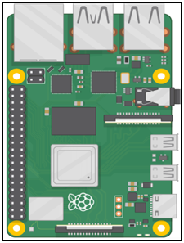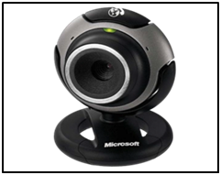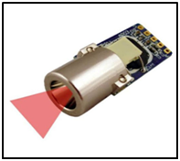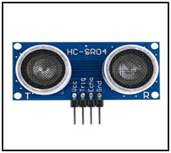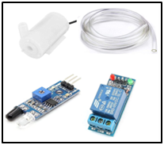
IR temperature sensor
USB Camera
Raspberry Pi
Proximity Sensor

Sanitizer Dispensing Unit
Cloud Database
Android App
Hardware Requirements:
- Raspberry Pi
- Proximity Sensor
- Sanitizer Dispensing Unit
  - 5V single channel relay
  - 5V water pump motor
  - 12V adapter
- IR temperature sensor
- Raspberry pi camera
- Android Mobile
- 16*2 LCD Display
Software Requirements:
- Android Studio

Module Description:
First Module:
In First module Integration of proximity sensor, finding nearby BLE devices and QR code detection using image processing will be done.
Second Module:
Data set images will be collected under the category of “Faces with Mask” and “Faces with No mask”. And in those images faces will be detected using dlib package(Based on CNN algorithm).
Third Module:
In third module, Features of Masked faces and faces without mask will be classified and stored in the deep learning model.
Fourth Module:
Fourth module will classify the faces to detect the mask from live video frames of webcam using trained CNN model. And Infrared Temperature sensor will integrated with master controller.
Fifth Module:
At final module Integration of cloud database and Android Application will be done and results will be uploaded to cloud database. If any rules or safety measures broken by employee then the notification will send to authority concerned through mail.

